**Murder Mystery: Solved**

**Done by Ngwee Simon Chidi**

One exciting thing about data analysis for me is acting like a detective, exploring your data to find answers that no one knew was there.

There was crime at SQL City. The crime happened on the 15th of January 2018 at The Funky Grooves Tour event.

Someone was murdered and it was my job as the data analyst detective to find who committed the crime.

After my investigation, I found out who committed the murder, more details on the murderer below.

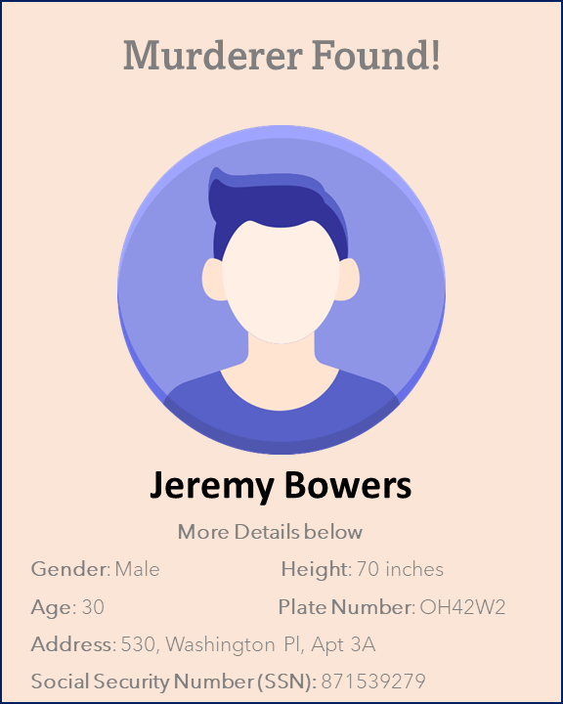

Do you want to know how I was able to use SQL to solve this case study? Just keep reading

**Here is how I solved the murder mystery**

Case study:

“*A crime has taken place and the detective needs your help. The detective gave you the crime scene report, but you somehow lost it. You vaguely remember that the crime was a murder that occurred sometime on Jan.15, 2018 and that it took place in SQL City. Start by retrieving the corresponding crime scene report from the police department’s database*.”

The Entity Relationship Diagram is provided below to solve the mystery.

Some key points to note going into the investigation

* Crime: Murder
* Date: Jan 15, 2018
* Location: SQL City

I started my analysis by checking the crime scene report using the key points above and I used the code below.

This helped me obtain some insights from the description column.

The description says:

“*Security footage shows that there were 2 witnesses. The first witness lives at the last house on "Northwestern Dr". The second witness, named Annabel, lives somewhere on "Franklin Ave".”*

This gave me a lead for further investigation. I went to acquire more details on the two witnesses from the person, driver license, income and get fit now membership table.

I used the codes below

I checked for more details about them

After getting more information on the witnesses. I decided to check if the witnesses attended a Facebook event on the date of the crime (Jan 15, 2018) and I also wanted to know the what the event name was.

I decided to also check if my witnesses were interviewed and if they were, then read their transcript.

I used the SQL script below to get the information I needed.

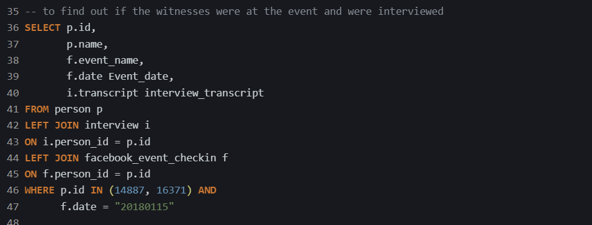

I discovered that the event name is “The Funky Grooves Tour” and this event also happened on the 15th of January 2018.

I took note of their statement of transcript for their interview.

**Witness 1 statement**:

“*I heard a gunshot and then saw a man run out. He had a "Get Fit Now Gym" bag. The membership number on the bag started with "48Z". Only gold members have those bags. The man got into a car with a plate that included "H42W".”*

**Witness 2 statement:**

*“I saw the murder happen, and I recognized the killer from my gym when I was working out last week on January the 9th.”*

Using the first witness description, I went to check for the individuals who fit the description. I put all that in my SQL query. The code I used is found below

The result from this query gave me just one person, His information is found below



It might be safe to assume he is the murderer but wait…. Lets check if this story matches that of the second witness

According to the second witness, she was at the gym on the 9th of January 2018, and she met him there. Let us confirm if he was there at that time with her.

I used the code below:

The results of this query confirms that he was there at that time with her.

Before I call the police to grab him, I just want to check if he was at “The Funky Grooves Tour” on the 15th of January 2018.

I used the query below to check for that.

I needed to get more details on the murderer, and I used the script below

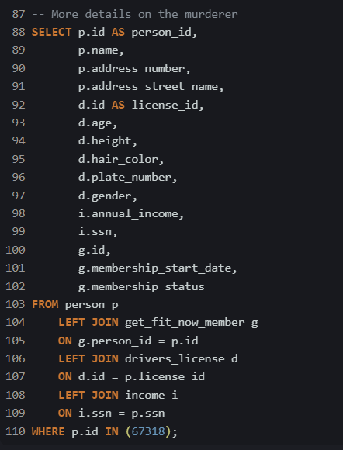

And there you have it, This is how I solved the case study. Interesting right

But wait…. I found something. I didn’t see this coming. I went to check if the murderer was interviewed and he made a statement

SQL script:



Murderer’s statement:

“*I was hired by a woman with a lot of money. I don't know her name but I know she's around 5'5" (65") or 5'7" (67"). She has red hair and she drives a Tesla Model S. I know that she attended the SQL Symphony Concert 3 times in December 2017.*”

Let’s find who the woman is with the description above (hopefully she hasn’t changed her hair color, lol)

I used the code below

Therefore, from the data investigation, The following answers were provided

Murderer: **Jeremy Bowers**

Who Hired Him? **Miranda Priestly**